LESSON – SMART goals pay off
My workbook

Purpose of this workbook: To help you capture your thoughts, decisions and actions from the online lesson – SMART goals pay off.

Your Name Firm Name

Date started Date Completed

What are your early thoughts on how you want this lesson on SMART goals to help you achieve greater success?

Now get started with your online lesson and SETTING THE SCENE– click here

Workbook exercises
SECTION A:
Work Out Your Personal Goals – your goals wheel...
Research suggests that working out your personal goals helps you achieve greater success compared with avoiding goal setting.
Using the SMART goals framework brings an even greater degree of success.
However, working on your goals can feel challenging. To make it easier and make it perfectly relevant to you, use the chart below and choose which of the 6 areas of ‘life goals’ you want to see improvement before you then make them SMART goals.
What does your goals-wheel look like?
Before we go into more detail, make a quick assessment about how you’d score these 6 areas of your life – here’s an example: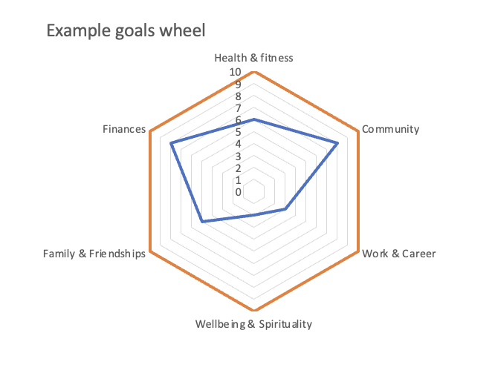
In this example (not you) you can see finances plus community have been scored at 8 – close to their ideal. Family & friendships and Health and Fitness need some work because they scored 5 and 6 respectively. And it looks like Wellbeing & Spirituality scoring 2 and Work & Career scoring 3 need some real attention.

Now, make this personal to you...
...how would you roughly score yourself against these 6 areas?
ACTION: Print this page with the blank goals wheel
Mark your scores out of 10 (where 10 is perfect, it couldn’t be better) then join the dots in blue to create your own personal goals wheel.

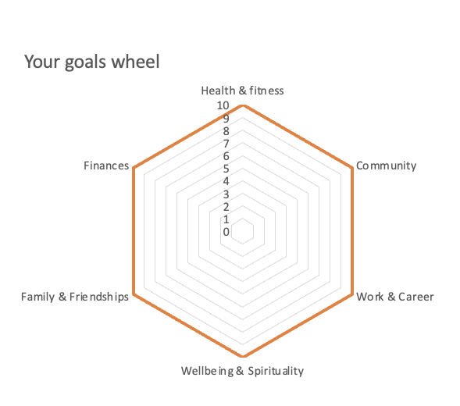
NB If you wish, replace any of the 6 labels with ones that matter more to you. For example, if you’re obsessed with climbing you might swap wellbeing for climbing.

Complete the goals wheel and you can quickly see which of your 6 life areas you’re most happy with and which you’re least happy with. You can also clearly see which areas of your life you’d like to give more attention to and set one or more SMART goals.
Before you go back to the online lesson it pays to answer this important question:
What could you change to achieve a higher goals wheel score?
To help you answer this question use the next exercise to identify some specific details about your goals wheel and confirm you have your scoring right.

Life goals assessment
In the table below you see the same labels from the goals wheel above (in column 1) with some thoughts on how to assess each area. Again, feel free to change the labels to best suit you.
Next, you’re asked, in column 2, to capture your personal thoughts on how you’re doing now.
Then in column 3 you’re now better placed to give yourself a score out of 10. And then identify the gap in column 4. This process helps bring a sense of accuracy to your goals wheel and signposts the specific goals you might choose to make SMART.
NB It’s important to be honest and truthful with yourself to get most value out of this workbook exercise. Please replace the example words and numbers to best reflect you in the 1 goals area you want to focus on.

1. Goal label | 2.How do you describe where you are now?  (type over the examples below) | 3.Give yourself a score out of 10... (1 = poor; 10 = perfect. Change the numbers below to your score) | 4.What’s the Gap?  (Subtract your numbers from 10 – record your score below. Replace the example numbers below)
Health and fitness  How’s your overall diet? Any changes you’d like to make to the way you eat? How do you feel during the day (tired, energetic, fatigued, etc)? How often do you exercise? | Example: “I eat a well-balanced diet mostly and exercise once a week – I should do more, but other things seem to take priority” | 6 | 4
Community  How happy are you with your contribution to your local or wider community? Is there something you want to do or volunteer for?  Are there any changes you’d like to make to this? | Example: “I help out at the rugby club and actively seek out giving opportunities to charities – I could do more in my village and get involved in a local group.” | 5 | 5
Work & career  How satisfied are you in your current work role?  Is your career on track? What could/should you change? Do you need to switch career paths or industries or role? | Example: “I’m in the right firm but think I could be doing better work. I’ve been do doing this role for a long time and need a change.” | 6 | 4
Wellbeing & Spirituality  How well are you managing your stress levels? How refreshed are you at the start of the week? Are you seeking support when feeling overwhelmed? How’s your quality of sleep? | Example: “Sometimes I sleep well sometimes I don’t. I deal with stress OK and when it gets on top of me, I call my counsellor” | 7 | 3
Family and Friendships  How well are you connected to friends and family? How satisfied are you with the quality of the relationships in your life? How often do you spend quality time with your loved ones? How easily do you connect with others? | Example: “I know I should be making more of an effort with my old friends. Regular calls and visits with parents are good but should message my sister more often” | 7 | 3
Finances  How comfortable are you with your current financial status? How well are you planning for the future Do you feel financially secure? | Example: “The savings and pension plan are on track (little & often)” | 8 | 2

When choosing which area to focus your SMART goal on you can focus on the goal area with the biggest gap – or if you prefer, focus on the area that’s most important to you (which may or may not have the biggest gap).
Well done for working through the goal area you’re focusing on (for now). With your decision made about which goal area to focus on, you’re now well-set to dive into learning about the SMART framework for setting goals.
Return to section B of the lesson or CLICK HERE.

SECTION B:
Set your own SMART goals
- Choose the goal area you want to focus on from your goals wheel exercise
- Complete the SMART goals grid below
- Set diary time in MSOutlook (or similar) with alarms (triggers) to help support your specific activity goals
- Share your SMART goals with friends/family/colleagues

Point 4 is an important addition. By sharing your goal with others, you bring peer pressure, support and accountability to your goal.
This example on the next page is in the health and fitness goals area. Simply write over your preferred SMART details or delete and choose the goals area that matters most to you:
PLEASE SCROLL DOWN…

1. Goal area | 2. Focus -  have; do; be: | 3. What do I need to do to support the success of this goal? | 4. SMART goal – Specific; Measurable; Achievable; Relevant; Timeline
Health and fitness | - Stop feeding myself biscuits and beer Monday-Friday (DO)  - Do 20 mins yoga from my yoga app every morning (DO)  - Use my watch alarm 30 mins earlier (not my phone alarm) to wake me up as the trigger to start my yoga without disturbing my partner (DO)  - See myself as someone who can achieve a 30-day everyday commitment (BE) | - Buy some non-alcohol beers for during the week  - Agree with partner no biscuit buying for 30-days  - Choose the best yoga app  - Set alarm at 6.15am every weekday  - Put diary appt in MSOutlook for 6.15 every weekday  - Tell my kids, colleagues, customers my goal | S. no biscuits no beer Monday-Friday  M. 20 minute – 30-day yoga challenge  A. only 20 mins yoga a day, only 30 days  R. Means I’ll be healthier and want to keep the yoga going  T. 30 days
Community
Work & career
Wellbeing & spirituality
Family & friendships
Finances

Excellent - the next step is to sense-check your SMART goal.
Return to SECTION C of the lesson -CLICK HERE

SECTION C:
Sense-check your SMART goal using the HAVE, DO and BE goals:
- To HAVE – possession – examples: car, watch, house, phone, kitchen, holiday
- To DO – activity – examples: climbing, meditating, dieting, exercising, timeliness
- To BE – character (intent) – examples: authentically caring, loving, respectful, curious, committed
When considering goal setting what often happens is a focus on HAVE goals.
The problem with an exclusively HAVE focus, on the outcome you seek, is that you ignore the behavioural (DO) and character (BE) aspects that are most often needed to achieve your outcome (HAVE) goal.
Now check your SMART goal in column 4 above to be sure you’re applying the HAVE, DO and BE elements of goal setting:
Rewrite your SMART goal here and assess it against the HAVE, DO and BE framework:

Now for some accountability to help you win...
Just to re-emphasise SMART goal step 4.
One of the most effective ways to help yourself achieve your goals is to seek out accountability support from others with a vested interest in your success.
If you’re setting work goals look to your manager and team members, if you’re setting health & fitness goals why not get your partner or friend involved too (it’s much more likely you’ll do ‘stuff’ if others are doing ‘stuff’ with you).
Name the people you want to share your SMART goal with here:

If you’re opting for self-accountability only, then construct timely reminders and mini-rewards for achieving key activity milestones (first day at the gym; first 5 x gym sessions complete; 20 x sessions).
List the reminders, alarms and triggers you want to use to help support your SMART goal behaviours:

You now have your SMART goal ready, diary time allocated with alarms/ triggers/alerts to prompt the action and the results you seek. By sharing your goal with others you bring commitment and support into play too.
Return to the lesson at Section D to learn how to overcome the stuff that gets in the way and holds you back - CLICK HERE

SECTION D:
Follow the 68-year-old knee and hip patients’ example:
- Think about your SMART goal
- Now work out what might stop you achieving your SMART goal. What hurdles, difficulties, challenges might get in your way?

- Decide in advance, on 1 or 2 things you can do to help overcome your anticipated challenges:

Go back to your Future Finest lesson on personal SMART goals and get ready for your next lesson - CLICK HERE

Further reflections on SMART goals pay off:
What positive reflections and examples did you observe?
What elements were less favourable or should be avoided?
What are the key lessons which can be directly applied to your business?

Goal Setting related accountability dates:
First Quarterly Review date:
Second Quarterly Review date:
Third Quarterly Review date:
Annual Review date:

