UHY International – Lucerne 9/10th September
Team engagement workbook

Agenda
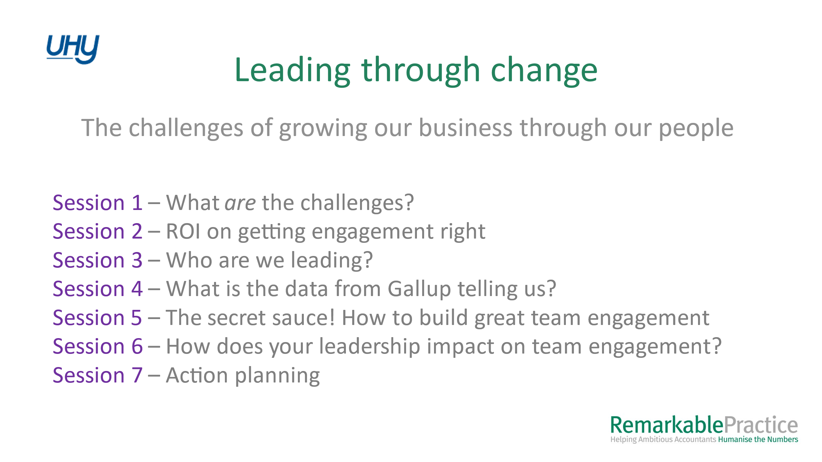

SECTION 1 – What are the challenges of growing our business through our people?
“Leading through change” – the challenges of growing our business through our people”

If we can create environments where people go to work every day, they make a contribution to something bigger than themselves, they learn something new, they feel safe, and they go home happy.” Garry Ridge

EXERCISE: What are the challenges of growing our business through our people??

